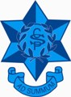
Camden Public School
John Street
Camden NSW 2570
Phone: 4655 8049
Fax: 4655 3269
Email: Camden-p.school@det.nsw.edu.au

5 April 2023

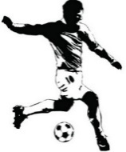

Macarthur P.S.S.A Gala Days
Boys Soccer

The junior and senior boys soccer teams will be walking to Onslow Oval, Camden on Friday 5 May, Friday 2 June and Friday 30 June 2023 to compete in this year’s gala days. Teams will leave school at approximately 9:15am and return by 3.10pm.

The cost for the gala day is $7.00 which includes the PSSA first aid levy.

Personal Injury Statement -
In the event of injury, no personal injury insurance cover is provided by the NSW Department of Education for students in relation to school sporting activities, physical education lessons or any other school activity. The Department’s public liability cover is fault-based and limited to breaches by the Department of its duty of care to students that may result in claims for compensation.

Parents/Carers are advised to assess the level and extent of their child/ward’s involvement in the sport program offered by the school, school sport zone, region and state school sport associations when deciding whether additional insurance cover is required prior to their child’s involvement in the program. Personal accident insurance cover is available through normal retail outlets.

Parents/Carers who have private ambulance cover need to check whether that cover extends to interstate travel and make additional arrangements as considered appropriate.
The NSW Supplementary Sporting Injury Benefits Scheme, funded by the NSW Government, provides limited cover for serious injury resulting in the permanent loss of a prescribed faculty or the loss of use of certain prescribed parts of the body. The Supplementary Scheme does not cover medical costs or dental costs. Further information can be obtained from https://www.icare.nsw.gov.au/injured-or-ill-people/sporting-injuries/payments/#gref. Further information regarding student accident insurance and private health cover is provided at: https://app.education.nsw.gov.au/sport/file/1449.

Concussion Statement - Concussion Clearance
The Australian Medical Association recommends students being symptom-free of concussion for 14 days before returning to sport. Students who have suffered a concussion within 14 days of the event, must provide written clearance from a medical practitioner prior to participating.

• If your child/ward sustains a concussion, or experiences any concussion symptoms, in the 14 days period prior to the event commencing, you must report this to team officials, and a medical clearance is required in order for your child/ward to participate in the event.

• Medical clearances can be attached to this consent form or can be submitted to team officials separately.

..2..

Students are to bring a school hat, lunch, recess, drinks and shin guards are compulsory. No soccer boots are to be worn. Camden Public School also has gala day socks available for purchase from our Uniform Shop, which may be worn on the gala days. The cost of the socks are $12.00.

Please advise the school as to any medical condition we need to be aware of for your child’s safety (eg anaphylaxis/asthma) in the information section of the permission note.

The Macarthur Primary School Sports Association has notified us that a Code of Conduct is to be signed by all players and parents. Please ensure both you and your child sign and return the attached Code of Conduct.

Parents and caregivers, please read, tick the check boxes, sign the permission slip and return to school office with $7.00 payment by Tuesday 2 May 2023.

Mr de Wilde Ms Price
Relieving Principal Boys Soccer Gala Day Co-Ordinator

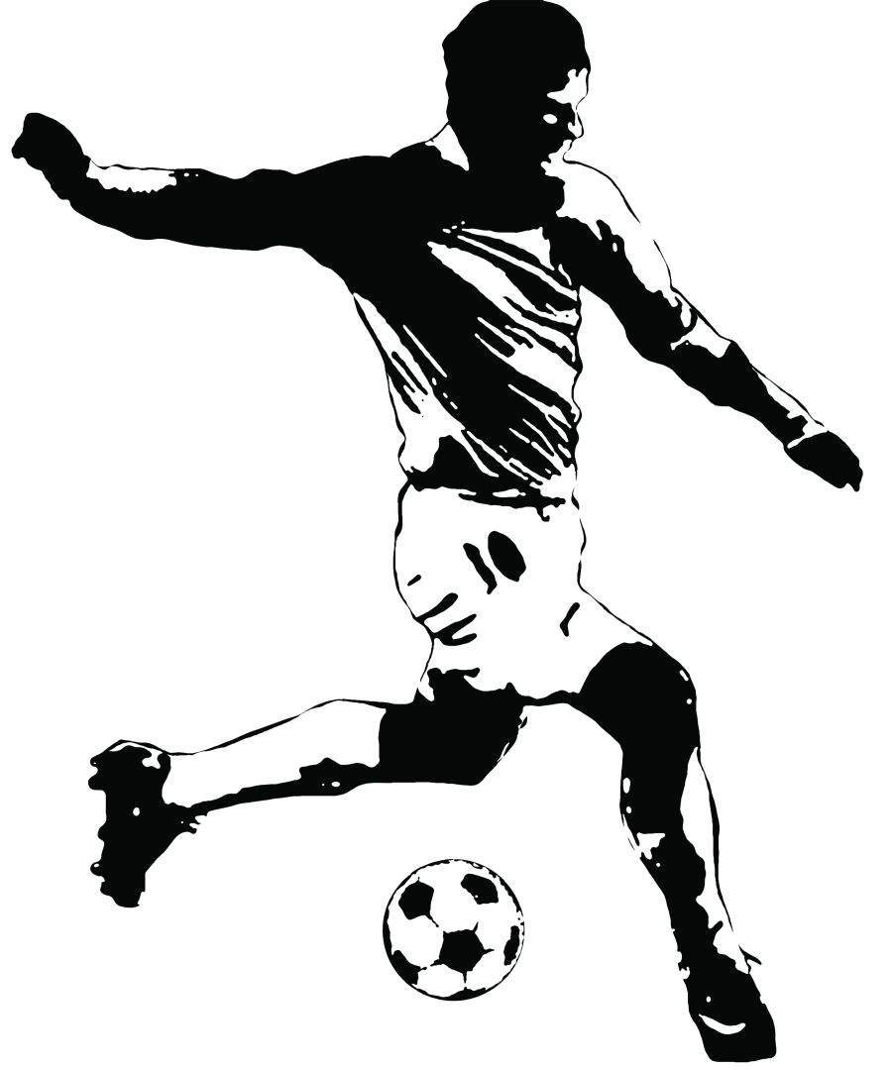
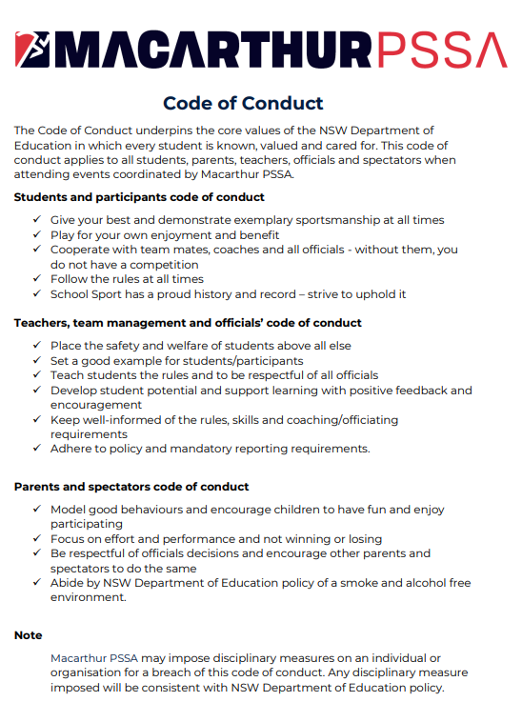

______________ ________________________ _______________________
Date Parent’s Name Player’s Name

______________ ________________________ _______________________
Date Parent’s Signature Player’s Signature

Camden Public School
John Street
Camden NSW 2570
Phone: 4655 8049
Fax: 4655 3269
Email: Camden-p.school@det.nsw.edu.au

CAMDEN PUBLIC SCHOOL – GALA DAY PERMISSION NOTE – BOYS SOCCER

I give permission for my child______________________________________________ of class ________________
to attend P.S.S.A Gala Days on Friday 5 May, Friday 2 June and Friday 30 June 2023 at Onslow Oval.

❑ I understand travel will be by bus.

❑ I can confirm that I understand that, in the event of injury, no personal injury insurance cover is provided by the NSW Department of Education for students in relation to school sporting activities, physical education lessons or any other school activity. (Personal injury statement)

❑ I acknowledge that if my child/ward sustains a concussion, or experiences any concussion symptoms, in the 14-day period prior to the event commencing, I am required to report this to team officials. I further acknowledge that, should this occur, my child/ward will only be permitted to participate in the event, if a medical clearance is provided. (Concussion statement)

Ambulance / medical treatment

❑ I affirm that, to the best of my knowledge, my child/ward has no medical condition or injury that places him/her at risk by participating in this sport activity.

❑ In the event of any accident or illness, I authorise the obtaining, on my behalf, of an ambulance and any such medical assistance that my child/ward may require. I accept full responsibility for expenses incurred.

❑ I enclose $7.00 payment for the 3 gala days. Please indicate payment method below:

❑ Cash  Eftpos or  POP Payment – Receipt No: _____________________________________________________

My child has the following medical condition/s and will require the listed medication to be taken to the gala day:-

____________________________________________________________________________________________________

________________________________________________________________________________________________________

Signed: _____________________________________________________ Date: __________________________________ Parent/Carer

