
Camden Public School
John Street
Camden
NSW 2570
Phone: 4655 8049
Fax: 4655 3269
Email: Camden-p.school@det.nsw.edu.au

1 March 2023

CAMDEN SHOW EXCURSION

On Friday 24 March 2023 all classes will be walking to the Camden Show, held at the Camden Showground - Onslow Oval.

Each class will be attending the show at various times throughout the day. All students receive free entry to the show as part of a school group, and will not need any spending money, as we do not allow students to purchase anything or to go on any rides. Individual teachers will send home notes or messages requesting parent helpers if required.
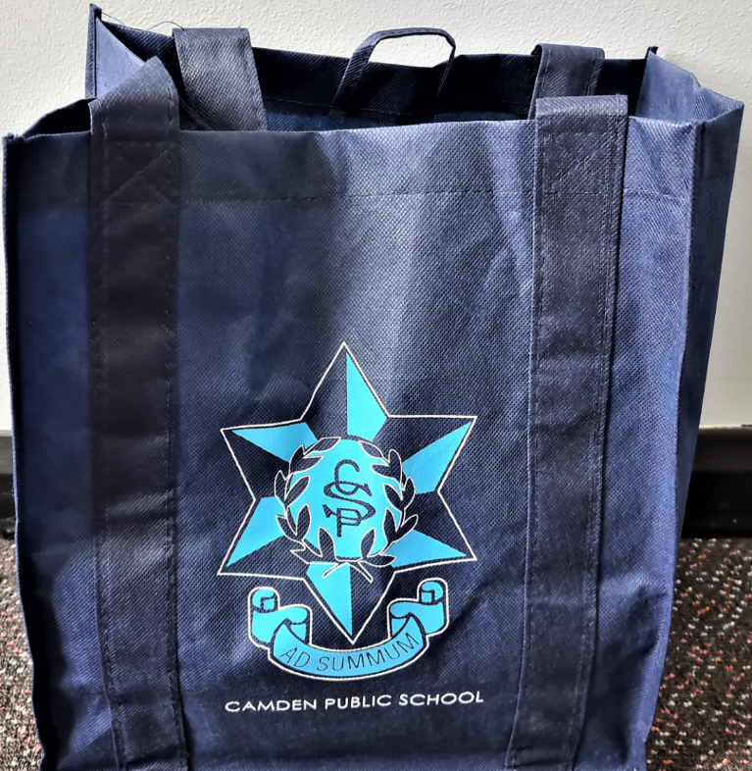

All students should wear school uniform (sports uniform is ideal),
a hat and sunscreen. Each student should also bring along a plastic
bag to carry drinks and possibly lunches in. The P&C uniform shop
have CPS excursion bags that are ideal for events such as this.
They can be purchased from the P&C uniform shop for $12.00.

During the Camden Show excursion, there is a possibility of students participating in the scout obstacle course which is designed for students of primary school age.

Please complete the permission note below (Please return to classroom teacher) to enable your child to participate in this fun excursion.

Mr de Wilde
Relieving Principal

CAMDEN SHOW PERMISSION NOTE – Please return to classroom teacher

I give permission for my child _____________________________________________ of class________________ to attend the walking excursion to the Camden Show on Friday 24 March 2023. I understand this excursion has the approval of the Principal and there is a possibility of my child participating in the scout obstacle course.

My child has the following medical condition/s: _______________________________________________________________________________________

My child requires the following medication to be taken to the Camden Show Excursion:

_______________________________________________________________________________________

Parent/Carer Signature ___________________________________ Date_____________________________

